CLUSTER-INN project as an MSCA Success Story for Marie Skłodowska-Curie Actions (MSCA), celebrating its 30th anniversary campaign

Prepared by prof Manuela Tvaronavičienė
February 24, 2026

Project 101129820 Cluster for innovative energy (CLUSTER-INN), the program "HORIZON-MSCA-2022-SE-01"
https://ec.europa.eu/info/funding-tenders/opportunities/portal/screen/opportunities/projects-details/43108390/101129820/HORIZON
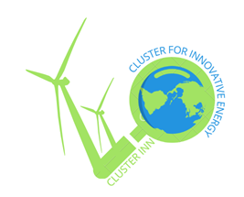
Coordinator: Vilnius Gediminas Technical University, Prof. Manuela Tvaronavičienė

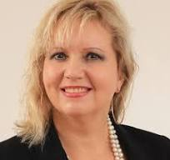

- A short testimonial
Energy generation and use obtained new urgency when Russia invaded Ukraine. European and other countries encountered harsh realities when problems related to energy availability and affordability had to be tackled. We build a cluster, which is a network of scientists in engineering, physics, economics and sociology, to find ways to become more resilient to external shocks caused by energy shortage, relying on energy from renewable sources. We introduce to citizens solutions, which scientists and practitioners generate together: how to choose a producer of solar panels, request installing it at specific angle depending on solar panel characteristic, and geographical region, where it is located, to have maximal efficiency, to develop culture of smart use of energy to enhance its stewardship, to cooperate with already established networks to be updated on technological solutions, offer new needs, which could shape direction of research based on up to date demand. Networking among scientists, manufacturers, and the public allows us to identify economic policy needs and advise policymakers together.

- One short quote
The interaction between society and scientists working on new technologies for solar energy exploitation, measuring economic feasibility, understanding manufacturers' interests, and studying end consumers' behavioural patterns enables the creation of a network for knowledge sharing, making societies more resilient to potential energy shocks.

Acknowledgements: all our consortium wants to express the greatest gratitude to Project Officer
Dr. Desislava Kolarova, who spends a lot of time and efforts guiding us and facilitating our valuable journey.
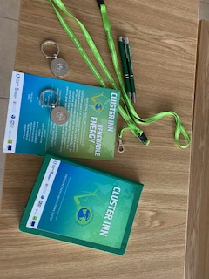
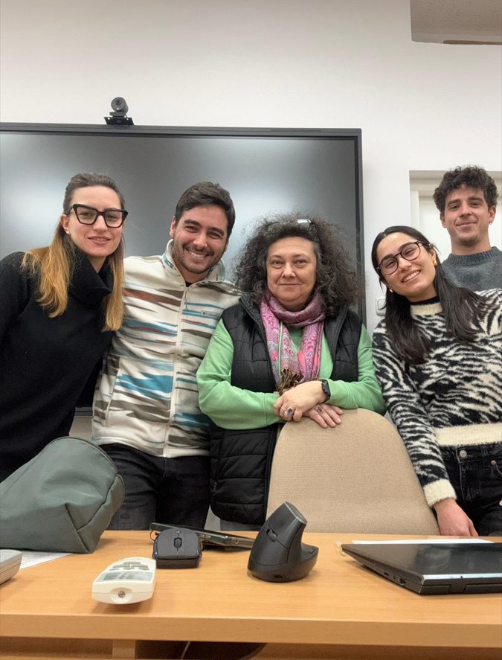
Cluster-inn communication for stakeholders and the public
Doctoral students in Poland
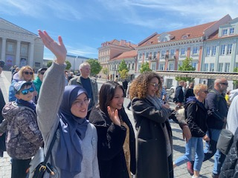
Doctoral students meet with the public in Vilnius Old Town, Lithuania

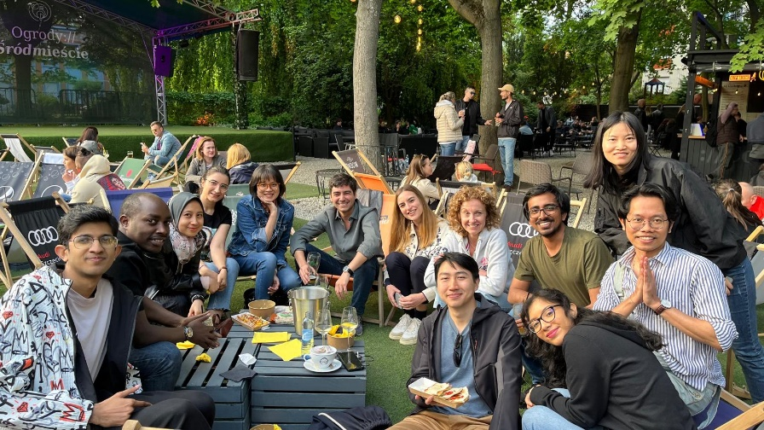

Sharing ideas in a meeting with international students in Poland

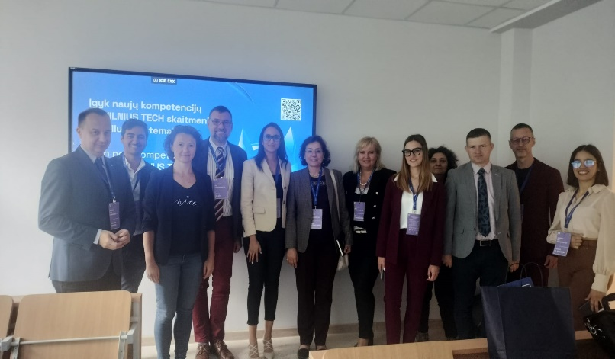

Consortium meeting in Vilnius, Lithuania
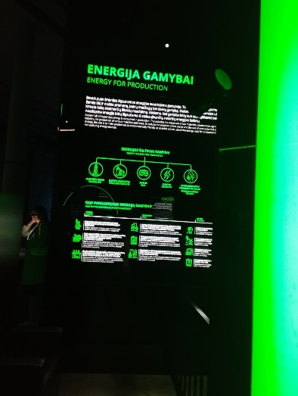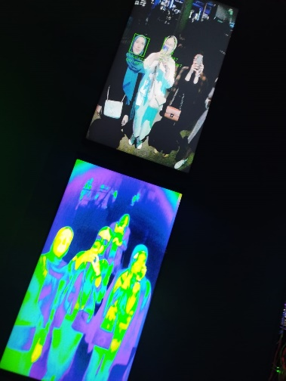
Energy technologies, Vilnius, Lithuania

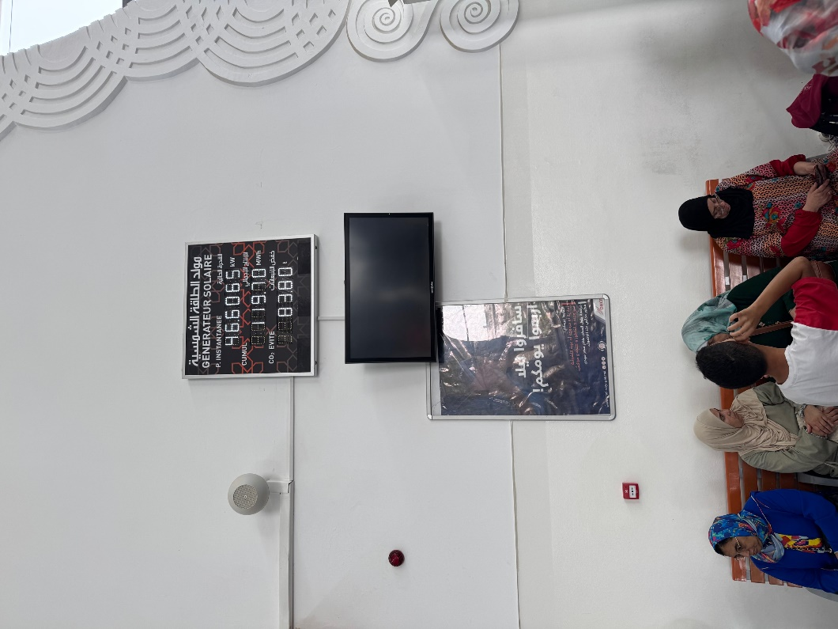
Solar energy in Fes railway station, Morocco

